PROJECT DOCUMENTATION

**LESSONS LEARNED REPORT**

| **Project:** | **E-Commerce Website for SKANDA**  **by Sarasi Samarasinghe.** |
| --- | --- |
| Release: | April 2022 |
| Date: | 24th March 2021 |
|  |  |
| **PRINCE2** |  |
|  |  |
| Author: | S. K. Helani Sihara Jayawardena, M. Sonali Silva |
| Owner: | Dr. Yasas Jayaweera (Project Executive) |
| Client: | SKANDA by Sarasi Samarasundara. |
| Document Ref: | LessonsLearnedReport_SKANDA |
| Version No: | 1.0 |

# 1 Lessons Learned Report History

## 

## 1.1 Document Location

This document is only valid on the day it was printed.

The source of the document will be found on the project's PC in location

## 1.2 Revision History

**Date of this revision:** 03/24/2022

**Date of Next revision:**

| **Revision date** | **Previous revision date** | **Summary of Changes** | **Changes marked** |
| --- | --- | --- | --- |
| 03/24/2022 |  | First issue |  |

## 1.3 Approvals

This document requires the following approvals.

Signed approval forms are filed in the Management section of the project files.

| **Name** | **Signature** | **Title** | **Date of Issue** | **Version** |
| --- | --- | --- | --- | --- |
| Dr Yasas Jayaweera |  | Project Board | 24/03/2022 | 1.0 |
| Adithya Narasinghe |  | Project Manager | 24/03/2022 | 1.0 |
| Mrs. Sarasi Samarasundara |  | Client | 24/03/2022 | 1.0 |

## 

## 1.4 Distribution

This document has been distributed to:

| **Name** | **Title** | **Date of Issue** | **Version** |
| --- | --- | --- | --- |
| Adithya Narasinghe | Project Manager | 24/03/2022 | 1.0 |
| M. Sonali Silva | Start-up Manager | 24/03/2022 | 1.0 |
| J. M. Pasindu Lawantha Bandara | Quality Manager | 24/03/2022 | 1.0 |
| Madapathage Don Kanishka Gimhan | Risk Manager | 24/03/2022 | 1.0 |
| S. K. Helani Sihara Jayawardena | Scheduling Manager | 24/03/2022 | 1.0 |

# 2 Table of Contents

1 Lessons Learned Report History **2**

1.1 Document Location 2

1.2 Revision History 2

1.3 Approvals 2

1.4 Distribution 3

2 Table of Contents **3**

Lessons Learned Log **4**

3 Purpose 5

4 Management/Quality Process Assessment 5

5 Deviations 6

6 Method/Tool Performance 6

7 Project Issues 7

8 Recommendations 8

9 Measurements of Effort 9

10 Statistics 10

**Table of figures**

Figure 1:Measurements of Effort  09

# Lessons Learned Log

## 3 Purpose

This lesson learned document focuses on the lessons the team has learned during the project that will be useful in future projects. The document contains the management framework used, techniques, and methodologies. This document also consists of all challenges which were faced by each team member as well.

## 4 Management/Quality Process Assessment

The project manager and the quality manager, respectively, were in charge of project management and quality. A few essential management and quality-control aspects are listed below.

* Initially, the project manager analyzed each team member's capabilities and allocated roles accordingly.
* Then the startup manager was able to get a complete understanding of the client's needs and get the project's fundamental criteria.
* The team successfully set and reached the deadlines and built the website accordingly.
* GitHub and Google Drive have been used to control versions of all documents to allow team members to work on the latest version of the reports and keep the project board updated on the project progress.

* The system's testing was successfully completed by the quality manager.

* The Risk Manager has been assessed all the risks and provided a mitigation plan in order to continue the project without any hassle.
* To meet the project's goals, team members completed all allocated duties, regardless of their assigned roles.
* The team members arranged frequent meetings with the client and the project board to update on the project progress. Each week, new features introduced to the system and how they function were presented to them for confirmation.
* The project team met with the project supervisor weekly, and the supervisor's feedback helped the team improve critical aspects, including time management, artefact development, and documentation.

* To handle project tasks, the project team used the ASANA project management tool. Apart from that, a WhatsApp group was created for members to interact.

Team members used online technologies such as Skype and Zoom to conduct group meetings due to the COVID-19 pandemic. The team had to deal with connectivity issues throughout those meetings.

## 5 Deviations

Not applicable.

## 6 Method/Tool Performance

From the starting point to the final release, the team members used the PRINCE2 project management method to complete the project. All the required documents were prepared using the PRINCE2 documentation templates provided in BREO.

The software tools that the project team used are:

* **Draw.IO**

Draw.IO is an open source web based modelling tool that supports creating UML diagrams for the system and software. The Draw.IO used to create UML diagrams for the project.

* **Figma**

The initial designing of the system interfaces was done by using Figma.

* **WordPress**

WordPress is a website framework used by more than 40% of the top 10 million websites around the world and is known for its ease of use, security, and scalability.

* **WooCommerce**

WooCommerce is the De facto e-commerce technology used with WordPress, which is used by more than 3 million websites and accounts for close to 30% of the top 1 million e-commerce sites around the world.

* **Selenium**Selenium is a UI testing framework used to run automated tests on a browser. This is used to conduct the quality testing.
* **GitHub**A repository hosting service used for the purpose of version controlling the documents.
* **Microsoft Office Package**Used for the purpose of documentation.
* **Google Docs**Used for the purpose of documentation.

## 7 Project Issues

This section will cover the challenges that each team member faces in their respective roles.

The project manager had a hard time keeping the team members in touch. Because of the COVID-19 pandemic, all members had trouble getting together in a physical location. As a result, team members were required to interact through WhatsApp and Zoom. It took additional effort to keep track of project deadlines and complete all duties linked to the submission before the deadline. By reviewing completed tasks and solving problems, the project manager led the group's other members. In addition, the project manager was in charge of settling team member disagreements by ensuring that all points of view were considered.

The scheduling manager was responsible for coordinating and scheduling all the meetings. In addition the scheduling manager was responsible for scheduling and monitoring the state of all the tasks that needed to be completed based on the dependencies and the importance of each item. Due to the covid pandemic, almost all of the project work happened virtually, which was both a blessing and a hindrance to the scheduling manager when scheduling and keeping in touch with the progress of the work.

The startup manager was responsible for acting as a bridge between the client and the development team. Communication between developers and the client is essential to complete a successful project. The startup manager had to examine the existing system to identify how it currently functions within the organisation. It was necessary to keep the client satisfied during the development stage, and the startup manager had to work harder to balance both the client and the team.

The project's quality manager had to deal with certain concerns regarding the quality of some produced papers and throughout the testing phase. Due to a client's delay, the testing portion of sprint 2 was slightly delayed, so he had to complete the tests in less time than planned. He was, however, able to manage and maintain the PRINCE2 project management standards that were necessary.

The project’s risk manager was responsible for handling and providing contingencies for all the risks associated with the project. This includes maintaining the risk log and coming up with contingencies for the pre-identified risks. When a problem occurs, it’s up to the risk manager to come up with the proper action to handle the risk, which can be following the already defined contingency plan, coordinating with the project manager to come up with a contingency plan or to reach out to the project board for guidance on how to overcome the risk.

The technical writer's position was taken over by the scheduling manager and the startup manager, who were responsible for creating project documentation. The project documents were completed using the templates given by the PRINCE2 methodology. The technical writer's biggest challenge was writing documents that were easy to understand for the customer. Since the customer was not a software engineer, the technical writer was responsible for clarifying the facts supplied by the subject-matter experts, including descriptions and references. Completing all the required documents before the weekly progress meeting was challenging.

The project, risk, and quality managers worked as the developers. When choosing which technology to use, they faced several obstacles. One developer had prior familiarity with relevant technology, whereas the other had none. As a result, the unskilled developer had to learn development tools while producing the artefact. Due to this, it has to be more efficient and less time-consuming. The system design was particularly tough to create because the web application was modified to meet the customer's needs.

## 8 Recommendations

* Understanding each team member's skill level in relevant areas is essential to increasing project productivity.
* After knowing their skills to work on each role, assigning members to the project roles such as project manager, startup manager, scheduling manager, quality manager, and risk manager should be chosen.
* In project management, using management tools like Trello may be quite beneficial.
* Appropriate communication technologies (Zoom meeting, WhatsApp group call) among the project team members allow for efficient and successful communication.

## 9 Measurements of Effort

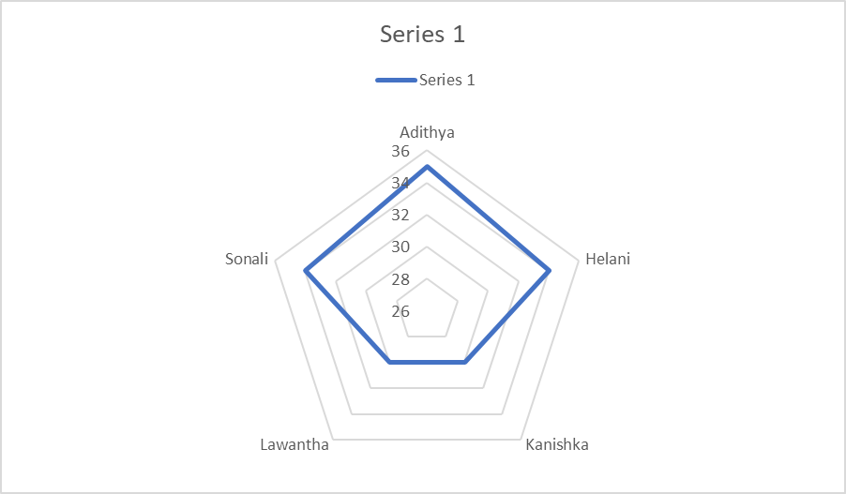

**Figure 1:Measurements of Effort**

In figure 1, indicates the effort of each group member on the project. The time is calculated by analysing completed tasks in each week by group members.

**Table 1 Contribution to SKANDA project**

| Member/Role | Assigned Tasks |
| --- | --- |
| Adithya Narasinghe  (Project Manager) | 1. Assigned team members to relevant tasks. 2. Manage project work. 3. Recheck all reports. 4. Supervise all team members. 5. Maintain the relationship between project board and team. 6. Present the project progress to the project board. |
| M. Sonali Silva  (Startup Manager) | 1. Maintain the relationship between client and project team. 2. Arrange client meetings and prepare client meeting minutes. 3. Gather requirements from the client. 4. Finalise the budget with the client. 5. Prepare all the reports that are assigned by the project manager. |
| J. M. Pasindu Lawantha Bandara (Quality Manager) | 1. Assess the overall project quality including the standard of the documents. 2. Prepare the quality checklist and the quality log. 3. Assist with the website implementation. 4. Prepare all the reports that are assigned by the project manager. |
| Madapathage Don Kanishka Gimhan  (Risk Manager) | 1. Assess all risks that are related to the project. 2. Provide a mitigation plan for identified risks. 3. Assist with the website implementation. 4. Prepare all the reports that are assigned by the project manager. |
| S. K. Helani Sihara Jayawardena  (Scheduling Manager) | 1. Schedule group meetings every week. 2. Prepared a gantt chart for planning and scheduling the project. 3. Prepare all the reports that are assigned by the project manager. 4. Update members about the due dates of the reports to make sure required reports are delivered on time. 5. Recorrecting documents after the project board’s feedback. |

Table 1 lists all of the essential duties that have been given to each team member. All participants actively engaged and contributed to completing the task of the SKANDA E-commerce website project.

## 10 Statistics

Quality assurance is essential because it uses statistical methods to assess product quality. This method significantly boosts productivity and performance while reducing human error.

The errors discovered after the initial test are listed below.

1. Checkout functionality did not work.
2. The website styling across different devices was not consistent.
3. All the items were not displayed on the website.
4. New customers couldn’t register to the website.

| **Total number of defects found by QA** | **Total no of defects rejected by customer /Dev team** | **Total number of errors found by customer** | **Test Effectiveness** |
| --- | --- | --- | --- |
| 7 | 3 | 0 | 31.25% |

**Test Effectiveness** = (No. of defects Resolved / Total No. of Defects Submitted) * 10

= (7-3) / (16+0) * 100

= 31.25%